

Application form for the 2026 James Van der Linden Medal

This initiative is supported by:



International Postal History Library vzw
&
James Van der Linden Postal History Research Center

Betekomsesteenweg 14, B3130 Begijnendijk, Belgium

email: iphlpostalhistory@gmail.com www.iphlpostalhistory.com

Nominations for James Van der Linden medal 2026

This medal honors the person and postal historian James Van der Linden.

For decades, James has been a beacon of light for many generations of postal histo- rians. His numerous publications, studies and articles testify to his in-depth research into postal history and are a must-read for every postal historian. His masterpiece, Les marques de Passages, is part of our postal history heritage and is a reference work that should not be missed.

The medal is awarded annually to a postal historian who, through their studies, pu- blications and dedication to postal history, has been and continues to be a source of inspiration for future generations of postal historians.

During the BOSTON2026 event, this medal will be awarded for the second time to a person who has made an exceptional contribution to postal history. Last year, the me- dal was awarded for the first time to Colin Tabeart (see https://iphlpostalhistory.com/ awards/).

Nominations are expected by 15 April 2026 at the latest using the application form and mailed to info@iphlpostalhistory.com. Please feel free to send as many info/at- tachements as you wish to motivate your application. Sign the application and email it in time.

On behalf of the selection committee,

Pol Wijnants President IPHL

Application form JVDLinden medal 2026
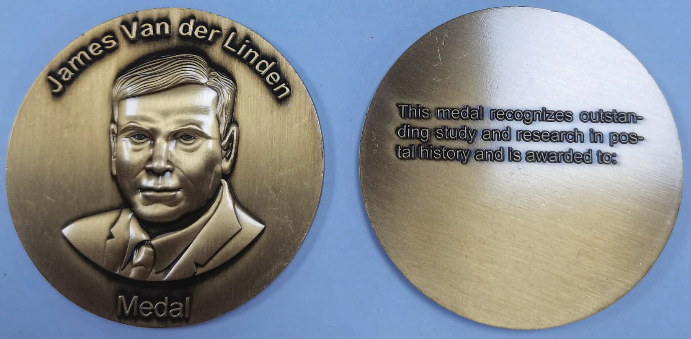
I, ........................................................................................................................................................
nominate the following postal historian for the James Van der Linden Medal 2026:
Name: ..................................................................................................................................
Address: ..............................................................................................................................
Email: ..................................................................................................................................

Reason for nomination:
............................................................................................................................................................
............................................................................................................................................................
............................................................................................................................................................
............................................................................................................................................................
............................................................................................................................................................
............................................................................................................................................................
............................................................................................................................................................
............................................................................................................................................................
............................................................................................................................................................
............................................................................................................................................................
............................................................................................................................................................
............................................................................................................................................................
............................................................................................................................................................
Yours faithfully,

email: .......................................................................................................

